## Limbo

* Limbo is a 2D puzzle and side-scroller platformer game where the MC’s character awakens in the edge of hell and the player’s objective is to search and find the MC’s sister. Whist the player is searching through all the levels the MC encounters very few human characters which is one way the game makes the player feel alone and scared. The player wins when they solve the last puzzle and is thrown into a pane of glass and back into the forest where he finds his sister
* The age rating for this game is 16+ and is aimed towards men and women.
* The main genres of the game is Adventure and Mystery
* The game has quite a lot of gore and very hard to solve puzzle games
* Developed and published by PlayDead studios.



## Inside

* Inside is a 2.5D Side-Scroller puzzle platformer game where the players MC is a young boy in an surreal environment with some colour that’s related to the environment whist solving environmental puzzles whist avoiding enemies and traps. There are occasional musical clues to what direction they should go or avoid. The player’s objective is to explore and find all the orbs throughout all the levels in order to end the game.
* The gae rating for this game is 15+ and is aimed towards men and women
* The games genre of the game is Adventure and Mystery
* The game has a lot of violence and is a very hard puzzle game yet there are a few positive role models and positive comments made in the game.
* 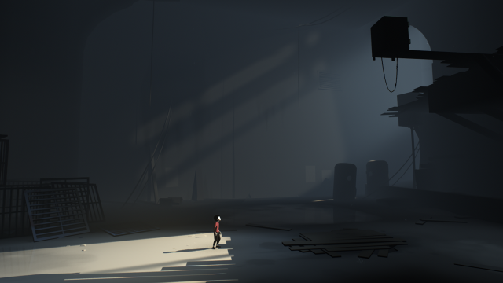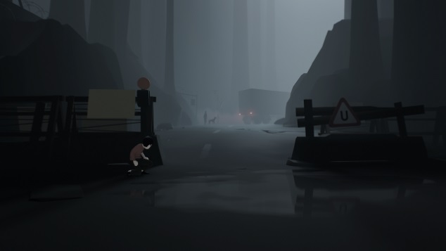Developed and Published by PlayDead studios